configurations can be created in two ways
- By running command
gcloud init and selecting an option to create a new configuration.

each new configuration can be created with different email id’s or different projects within the same mail id.

Here, I have created a configuration named j11 and used different email id for setting up a new account.

- 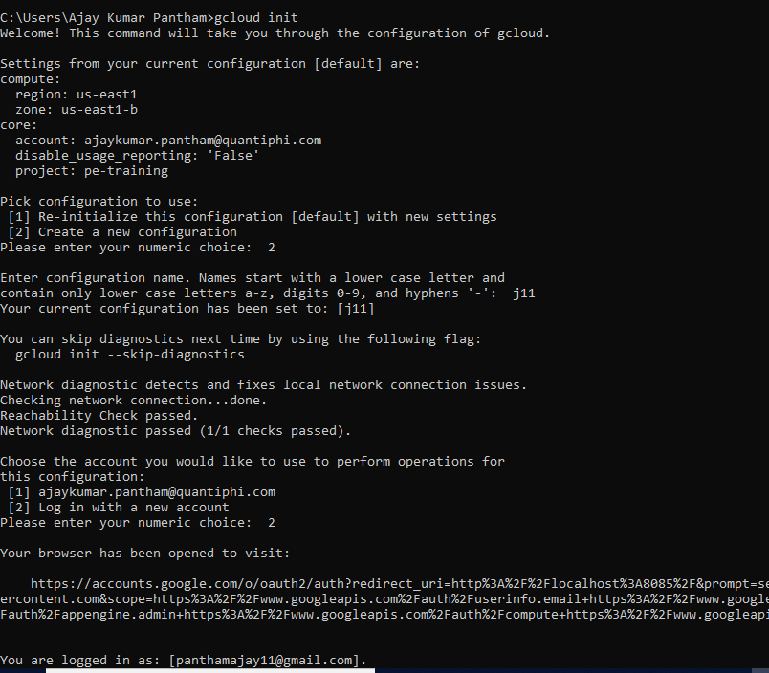

After setting up the account, you can create a new project or else you can opt for an existing one.

I have created a new project named : j11-first

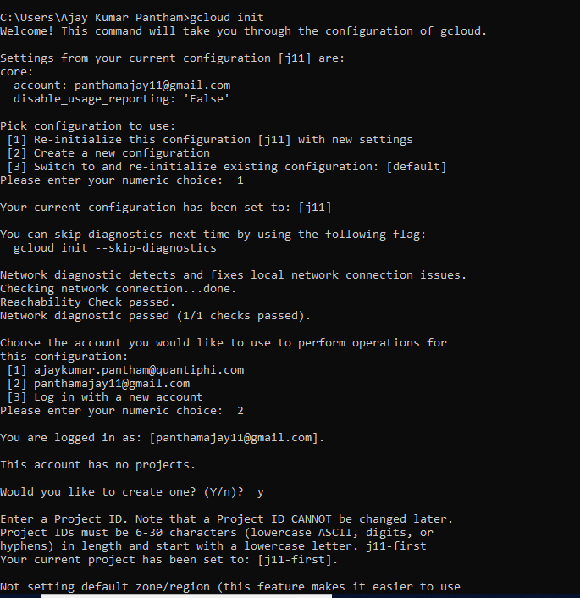

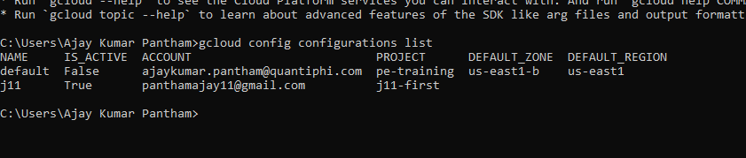

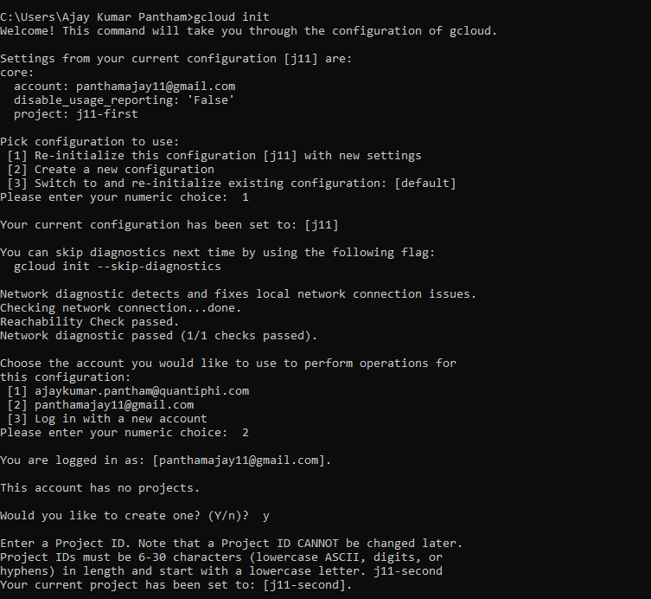

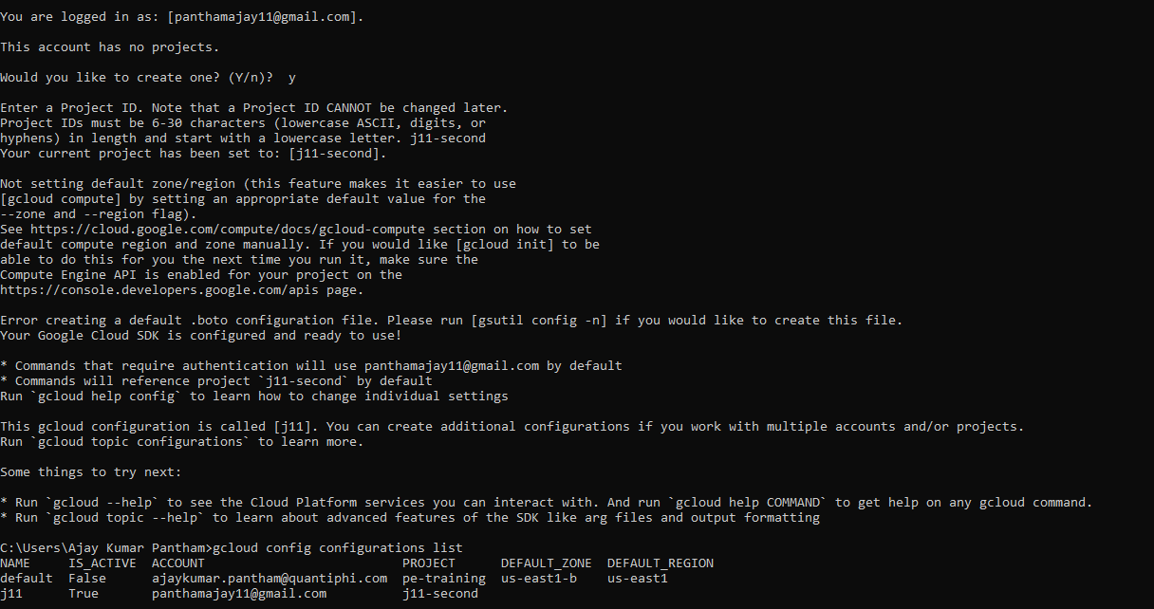

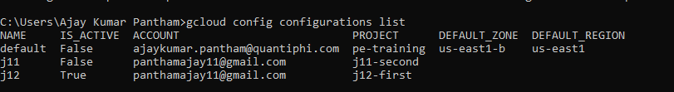
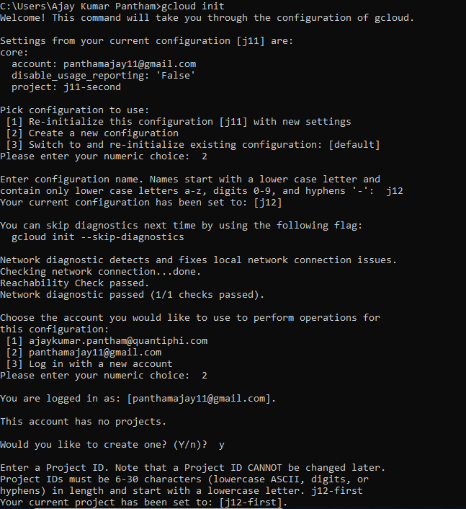

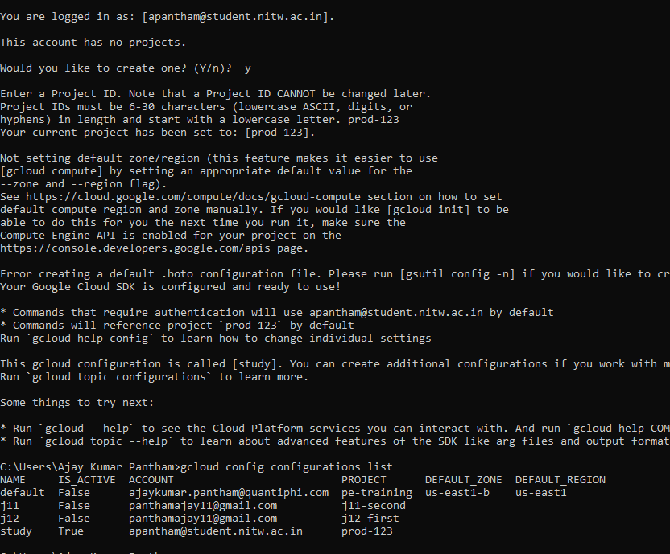

Using gcloud commands directly we create and activate the configurations.
Gcloud config configurations create deva

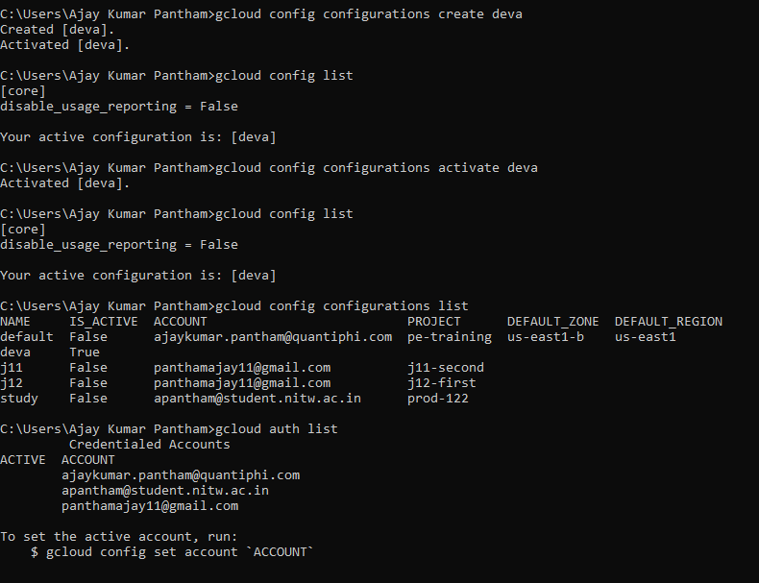

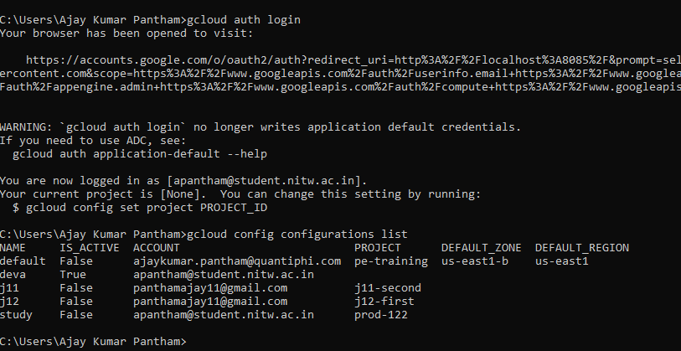

Switching between accounts:

Using gcloud auth login

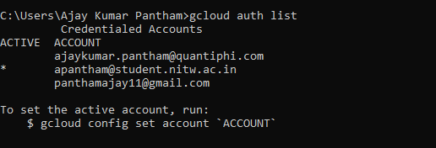

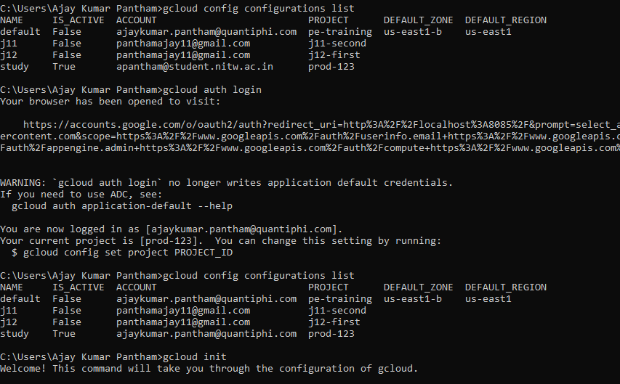

U can also switch between accounts by activating the required configuration to which your account is attached.
Intially j11 config. Is activate but after running command gcloud config configurations activate study
study config. has became activated.

Thus we can switch between two accounts.

